**Skill Based Practical 1: .NET Programming Lab (23UAMSP304)**

1. Write a program to design an Arithmetic Calculator using Buttons and Textbox.

**Form Design**

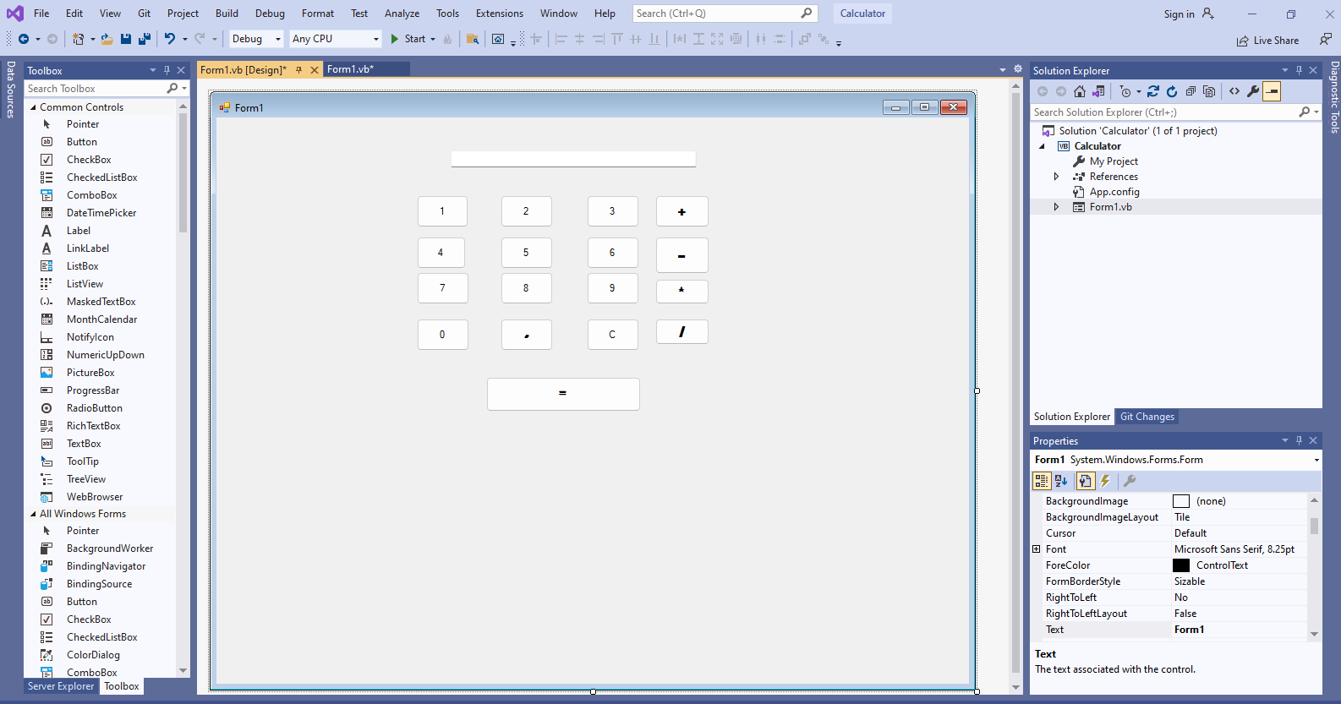

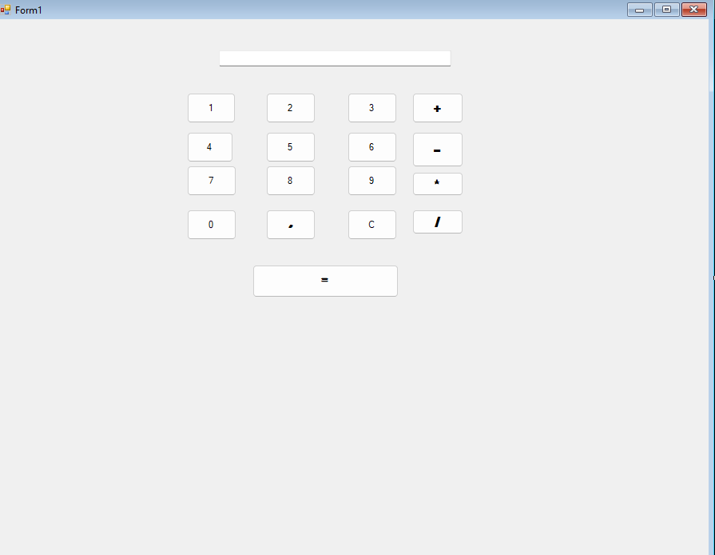

**Codings**

Public Class Form1

Dim firstnum As Decimal

Dim secondnum As Decimal

Dim answer As Decimal

Dim operation As String

Private Sub Button1_Click(sender As Object, e As EventArgs) Handles Button1.Click

TextBox1.Text = TextBox1.Text & 1

End Sub

Private Sub Button2_Click(sender As Object, e As EventArgs) Handles Button2.Click

TextBox1.Text = TextBox1.Text & 2

End Sub

Private Sub Button3_Click(sender As Object, e As EventArgs) Handles Button3.Click

TextBox1.Text = TextBox1.Text & 3

End Sub

Private Sub Button4_Click(sender As Object, e As EventArgs) Handles Button4.Click

TextBox1.Text = TextBox1.Text & 4

End Sub

Private Sub Button5_Click(sender As Object, e As EventArgs) Handles Button5.Click

TextBox1.Text = TextBox1.Text & 5

End Sub

Private Sub Button6_Click(sender As Object, e As EventArgs) Handles Button6.Click

TextBox1.Text = TextBox1.Text & 6

End Sub

Private Sub Button7_Click(sender As Object, e As EventArgs) Handles Button7.Click

TextBox1.Text = TextBox1.Text & 7

End Sub

Private Sub Button8_Click(sender As Object, e As EventArgs) Handles Button8.Click

TextBox1.Text = TextBox1.Text & 8

End Sub

Private Sub Button9_Click(sender As Object, e As EventArgs) Handles Button9.Click

TextBox1.Text = TextBox1.Text & 9

End Sub

Private Sub Button10_Click(sender As Object, e As EventArgs) Handles Button10.Click

TextBox1.Text = TextBox1.Text & 0

End Sub

Private Sub Button11_Click(sender As Object, e As EventArgs) Handles Button11.Click

TextBox1.Text = TextBox1.Text & "."

End Sub

Private Sub Button12_Click(sender As Object, e As EventArgs) Handles Button12.Click

TextBox1.Text = " "

TextBox1.Focus()

End Sub

Private Sub Button13_Click(sender As Object, e As EventArgs) Handles Button13.Click

firstnum = Val(TextBox1.Text)

TextBox1.Text = " "

operation = "+"

End Sub

Private Sub Button14_Click(sender As Object, e As EventArgs) Handles Button14.Click

firstnum = Val(TextBox1.Text)

TextBox1.Text = " "

operation = "-"

End Sub

Private Sub Button15_Click(sender As Object, e As EventArgs) Handles Button15.Click

firstnum = Val(TextBox1.Text)

TextBox1.Text = " "

operation = "*"

End Sub

Private Sub Button16_Click(sender As Object, e As EventArgs) Handles Button16.Click

firstnum = Val(TextBox1.Text)

TextBox1.Text = " "

operation = "/"

End Sub

Private Sub Button17_Click(sender As Object, e As EventArgs) Handles Button17.Click

secondnum = Val(TextBox1.Text)

If operation = "+" Then

answer = firstnum + secondnum

End If

If operation = "-" Then

answer = firstnum - secondnum

End If

If operation = "*" Then

answer = firstnum * secondnum

End If

If operation = "/" Then

answer = firstnum / secondnum

End If

TextBox1.Text = answer

End Sub

End Class

1. Write a program to create Digital Clock using Label and Timer.

**Form Design**

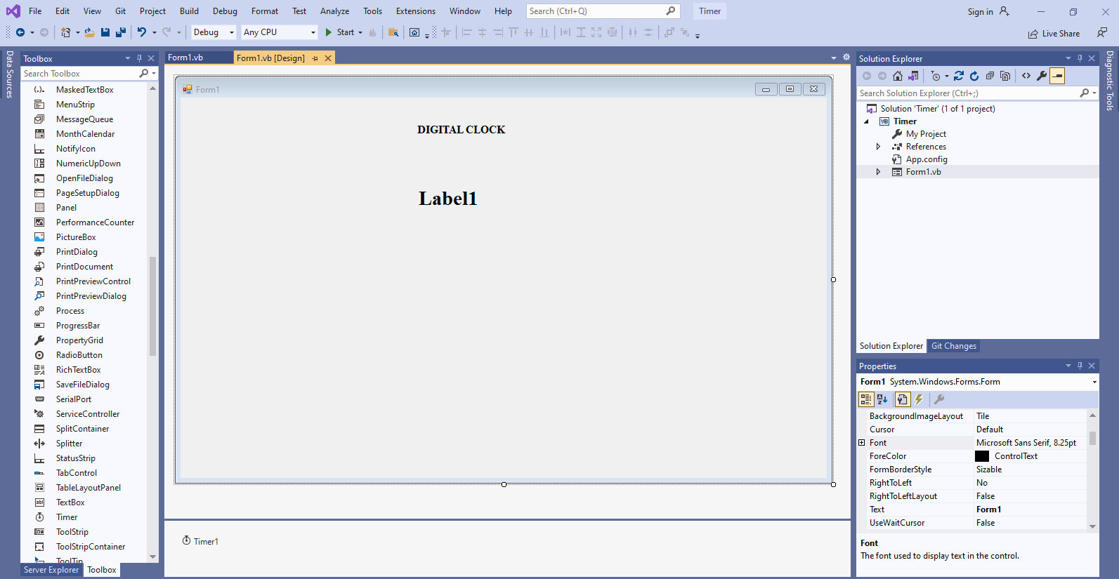

**Coding**

Public Class Form1

Private Sub Form1_Load(sender As Object, e As EventArgs) Handles MyBase.Load

Timer1.Start()

End Sub

Private Sub Timer1_Tick(sender As Object, e As EventArgs) Handles Timer1.Tick

Label1.Text = DateAndTime.Now

End Sub

End Class

**OUTPUT**

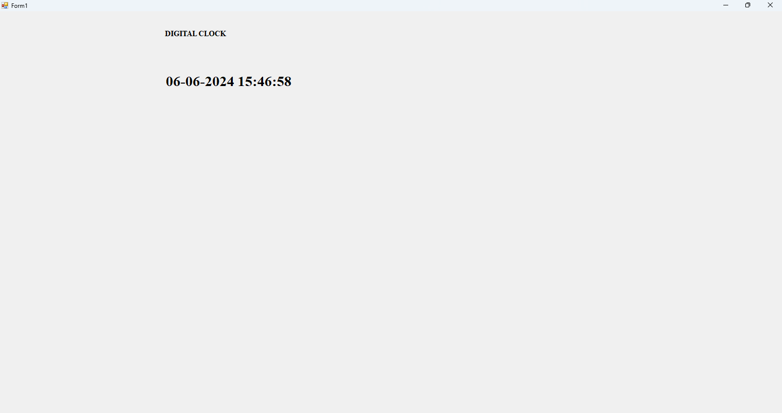

1. **Write a program to create Menus, Status Bars and Tool Bars.**

**Form Design**

**Form 1**

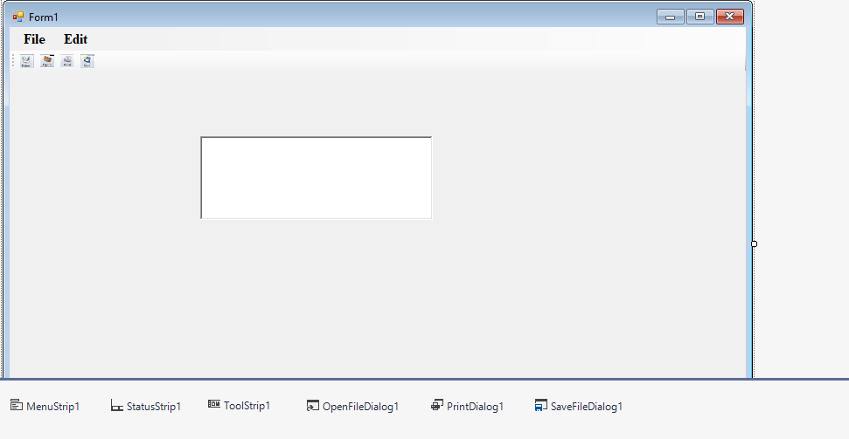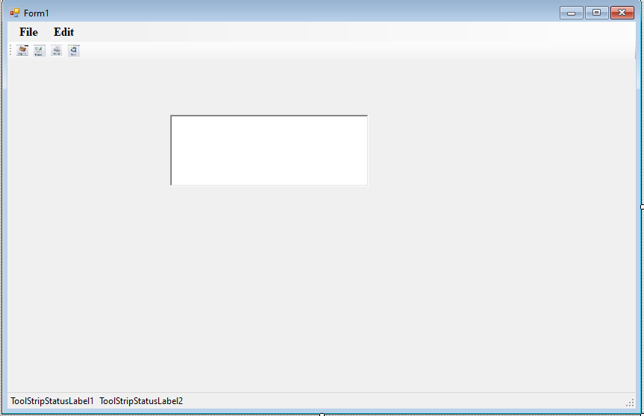

**Form 2**

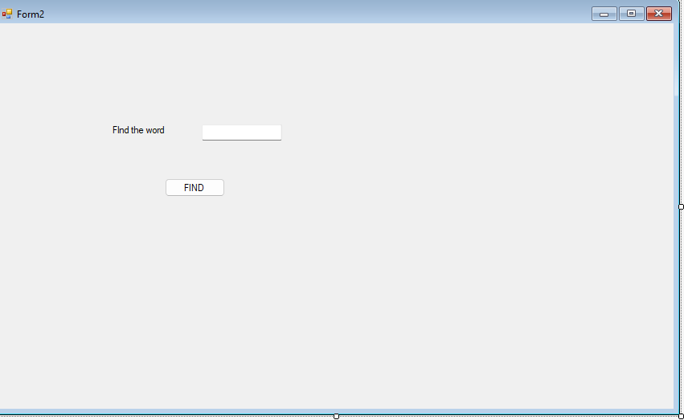

**Coding**

**Form1**

Public Class Form1

Private Sub NewToolStripMenuItem_Click(sender As Object, e As EventArgs) Handles NewToolStripMenuItem.Click

MsgBox("New Menuitem selected")

End Sub

Private Sub OpenToolStripMenuItem_Click(sender As Object, e As EventArgs) Handles OpenToolStripMenuItem.Click

OpenFileDialog1.ShowDialog()

End Sub

Private Sub SaveToolStripMenuItem_Click(sender As Object, e As EventArgs) Handles SaveToolStripMenuItem.Click

SaveFileDialog1.ShowDialog()

End Sub

Private Sub PrintToolStripMenuItem_Click(sender As Object, e As EventArgs) Handles PrintToolStripMenuItem.Click

PrintDialog1.ShowDialog()

End Sub

Private Sub ExitToolStripMenuItem_Click(sender As Object, e As EventArgs) Handles ExitToolStripMenuItem.Click

Close()

End Sub

Private Sub CutToolStripMenuItem_Click(sender As Object, e As EventArgs) Handles CutToolStripMenuItem.Click

RichTextBox1.Cut()

End Sub

Private Sub CopyToolStripMenuItem_Click(sender As Object, e As EventArgs) Handles CopyToolStripMenuItem.Click

RichTextBox1.Copy()

End Sub

Private Sub PasteToolStripMenuItem_Click(sender As Object, e As EventArgs) Handles PasteToolStripMenuItem.Click

RichTextBox1.Paste()

End Sub

**Form 2**

Public Class Form2

Private Sub Button1_Click(sender As Object, e As EventArgs) Handles Button1.Click

Form1.RichTextBox1.Find(TextBox1.Text)

End Sub

End Class

Output

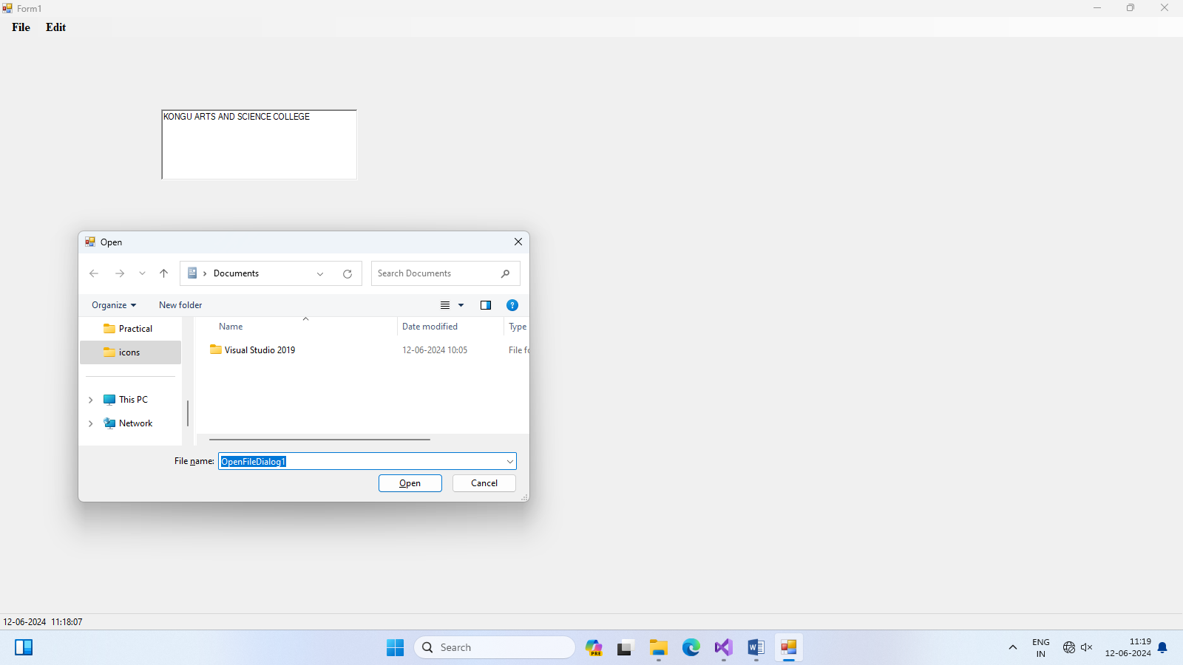

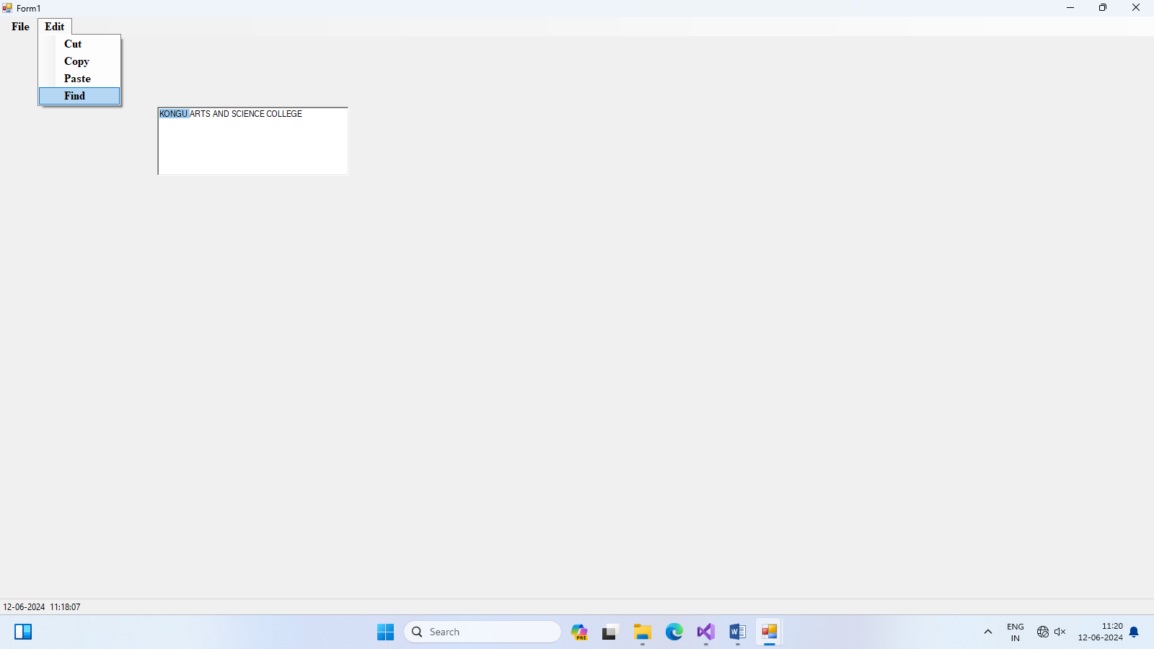

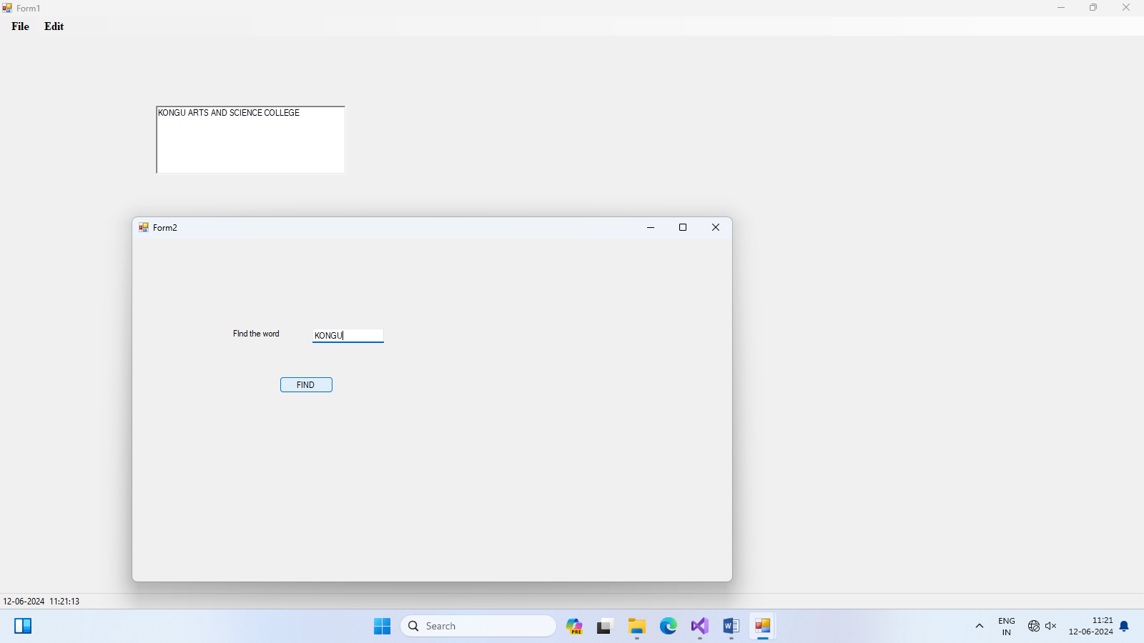

1. **Write a program for Keyboard and Mouse events.**

**Form Design**

**Form1**

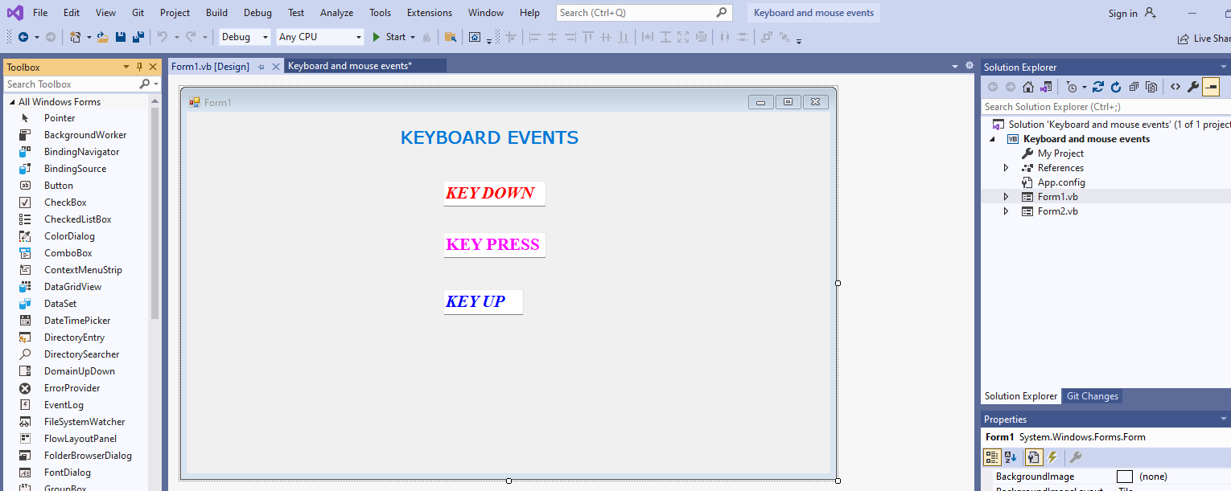

**Form 2**

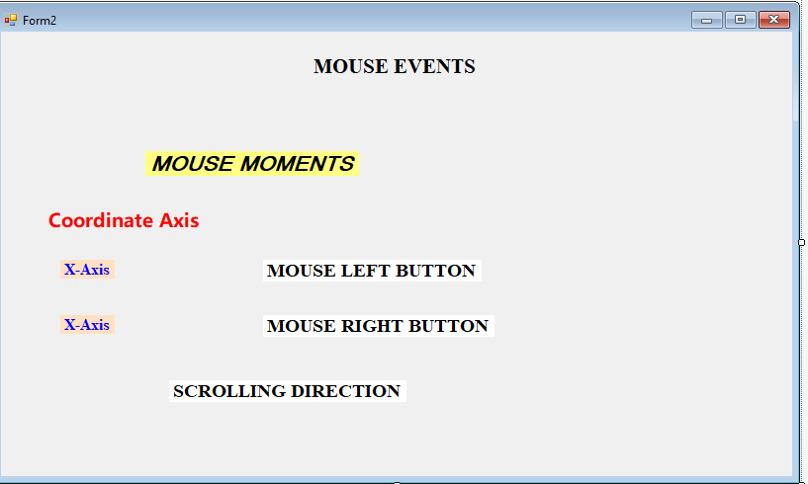

**Coding**

**Form 1**

Public Class Form1

Private Sub TextBox1_KeyDown(sender As Object, e As KeyEventArgs) Handles TextBox1.KeyDown

If e.KeyCode = Keys.Enter Then

MsgBox("FOR KEY DOWN-ENTER KEY PRESSED")

End If

End Sub

Private Sub TextBox2_KeyPress(sender As Object, e As KeyPressEventArgs) Handles TextBox2.KeyPress

If e.KeyChar = Convert.ToChar(13) Then

MsgBox("FOR KEY PRESS-ENTER KEY PRESSED")

End If

End Sub

Private Sub TextBox3_KeyUp(sender As Object, e As KeyEventArgs) Handles TextBox3.KeyUp

If e.KeyCode = Keys.Enter Then

MsgBox("FOR KEY UP-ENTER KEY PRESSED")

End If

End Sub

End Class

**Form 2**

Public Class Form2

Private Sub Form2_MouseMove(sender As Object, e As MouseEventArgs) Handles Me.MouseMove

Label4.Text = e.X

Label5.Text = e.Y

End Sub

Private Sub Label2_MouseEnter(sender As Object, e As EventArgs) Handles Label2.MouseEnter

Label2.Text = "MOUSE IS INSIDE NOW"

End Sub

Private Sub Label7_Click(sender As Object, e As EventArgs) Handles Label7.Click

End Sub

Private Sub Label2_MouseLeave(sender As Object, e As EventArgs) Handles Label2.MouseLeave

Label2.Text = "MOUSE IS NOT INSIDE NOW"

End Sub

Private Sub Form2_MouseDown(sender As Object, e As MouseEventArgs) Handles Me.MouseDown

If e.Button = MouseButtons.Left Then

Label6.Text = "PRESSED"

ElseIf e.Button = MouseButtons.Right Then

Label7.Text = "PRESSED"

End If

End Sub

Private Sub Form2_MouseUp(sender As Object, e As MouseEventArgs) Handles Me.MouseUp

If e.Button = MouseButtons.Left Then

Label6.Text = "UNPRESSED"

ElseIf e.Button = MouseButtons.Right Then

Label7.Text = "UNPRESSED"

End If

End Sub

Private Sub Form2_MouseWheel(sender As Object, e As MouseEventArgs) Handles Me.MouseWheel

If e.Delta < 0 Then

Label8.Text = "DOWN DIRECTION"

End If

If e.Delta > 0 Then

Label8.Text = "UP DIRECTION"

End If

End Sub

End Class

**Output**

**Form1**

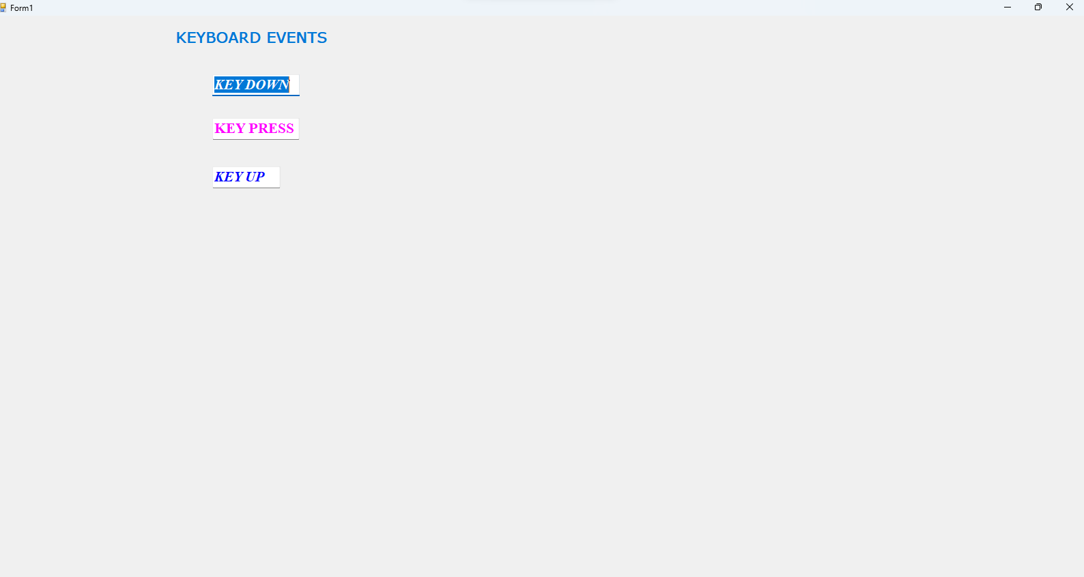

**Form 2**

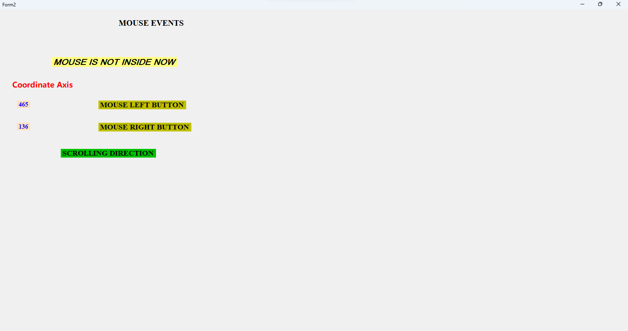

1. Write a program to select image from list box and display it in the picture box.

Form Design

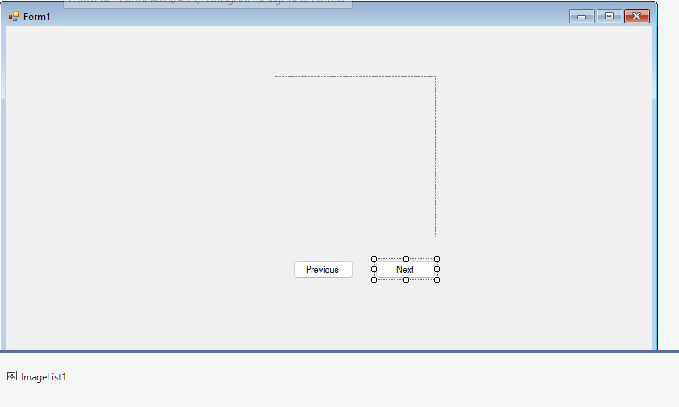

Coding

Public Class Form1

Dim idx As Integer

Private Sub Form1_Load(sender As Object, e As EventArgs) Handles MyBase.Load

idx = 0

displayimage()

End Sub

Private Sub displayimage()

PictureBox1.Image = ImageList1.Images(idx)

End Sub

Private Sub btnprevious_Click(sender As Object, e As EventArgs) Handles btnprevious.Click

idx = idx - 1

If idx < 0 Then

idx = ImageList1.Images.Count - 1

End If

displayimage()

End Sub

Private Sub btnnext_Click(sender As Object, e As EventArgs) Handles btnnext.Click

idx = (idx + 1) Mod ImageList1.Images.Count

displayimage()

End Sub

End Class

**OUTPUT**

